VPC Challenge

Use Case: Setting up Transit Gateway and VPC Endpoints for a Multi-VPC Architecture
Scenario:
A large organization is migrating its on-premises infrastructure to the AWS cloud.
The organization's architecture involves multiple VPCs for different departments and applications, each requiring secure communication with centralized services and external resources.
The IT team needs to design and implement a scalable and efficient network architecture to accommodate the organization's growth and ensure robust connectivity between VPCs and external services.
Objectives:
- Design and deploy a scalable network architecture using AWS Transit Gateway to simplify network connectivity between multiple VPCs.
- Configure VPC endpoints to securely access AWS services without internet gateways or NAT gateways, ensuring data privacy and minimizing exposure to external threats.

Set up a VPC endpoint.
A VPC Endpoint is like a private door from our VPC to AWS services.
Ec2 instance in a private subnet can reach AWS service privately, without internet.
We need this VPC Endpoint because private ec2 cannot reach like to s3 etc
We need NAT gateway to go to internet.
So we don’t need NAT with VPC Endpoint.

First we should create VPC
Public subnet and private subnet and also public and private route tables
And create two ec2 instances and connect first instance with public IP and check the communication.
Now connect to second instance of private IP using jump server now check the communication.
Create a end point and attach that endpoint to private route table.
Now communication will happen.
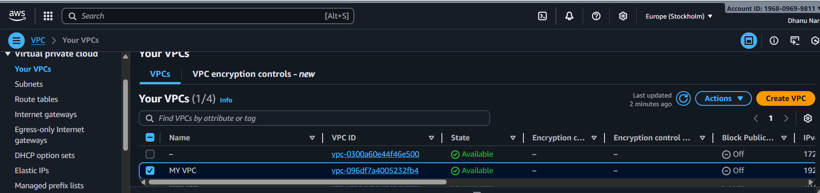
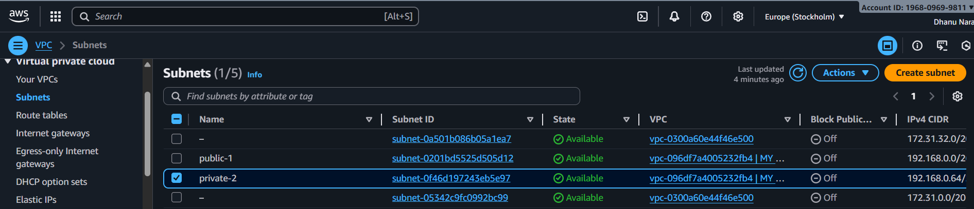
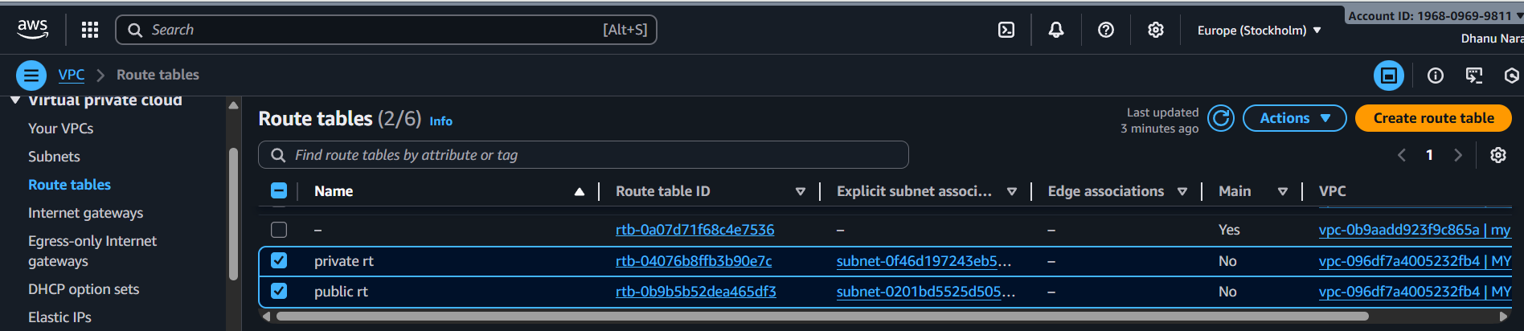
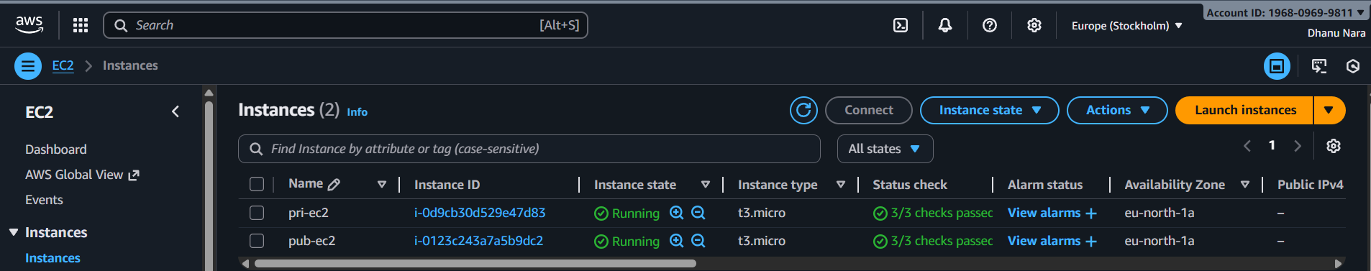
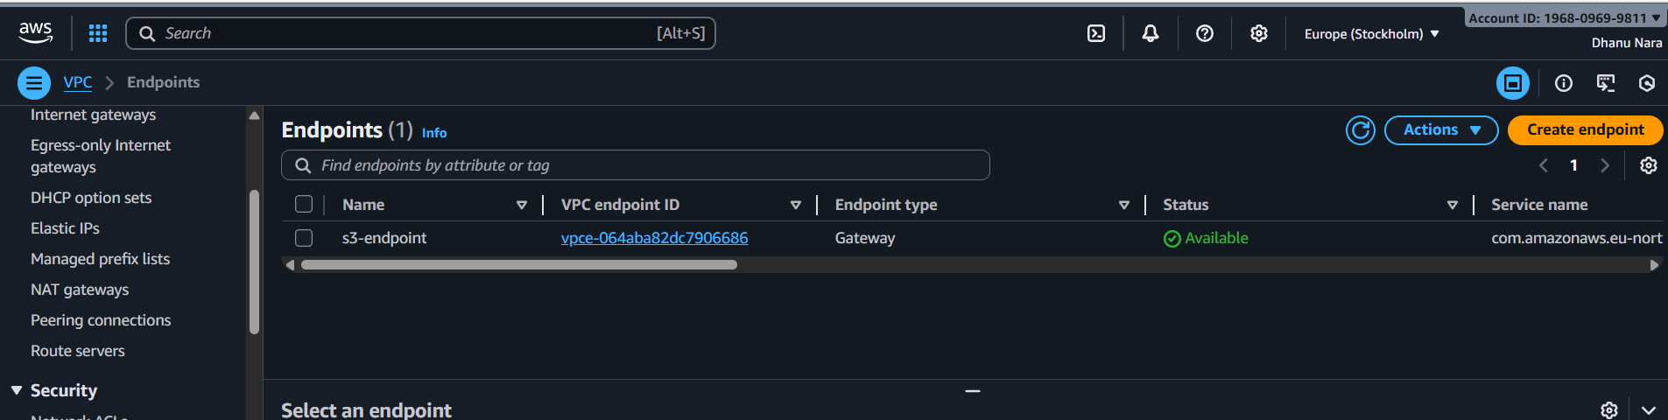
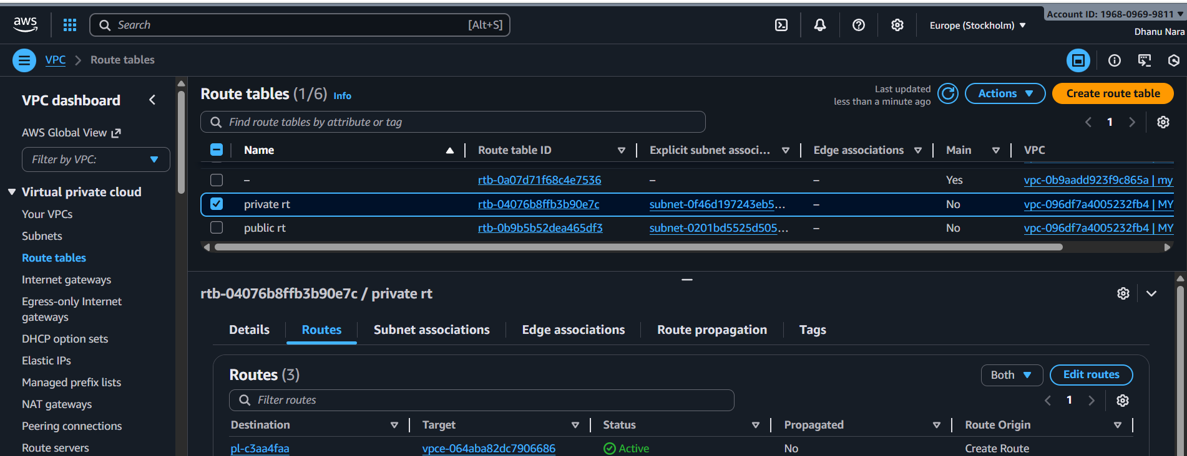
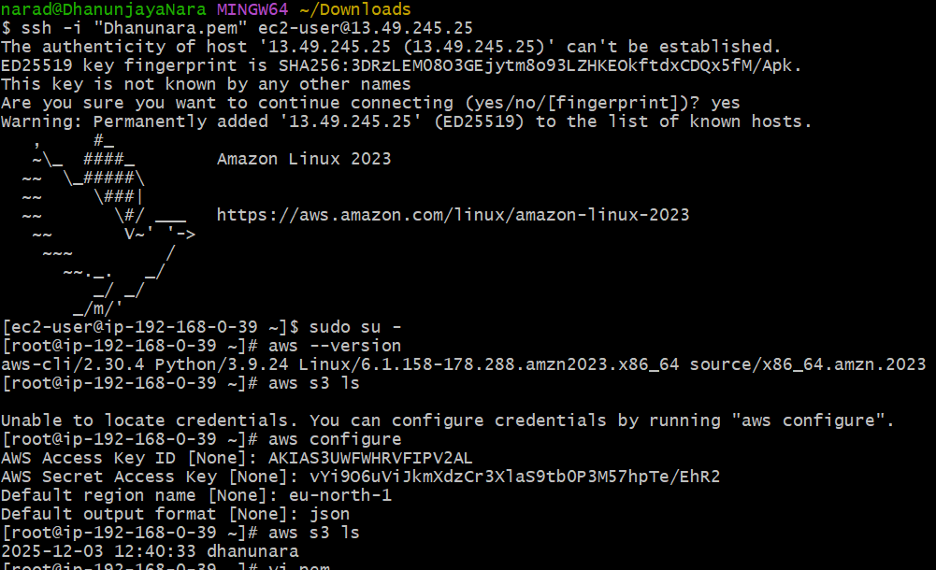
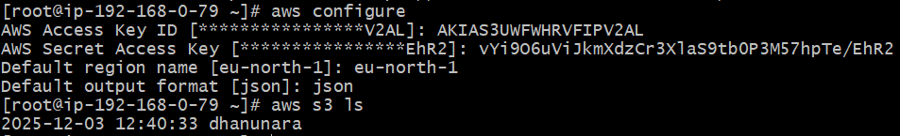

Set up a VPC Transit Gateway.
Transit gateway is used for connecting multiple VPCs.
We should first create multiple VPCs which we are going to connect.
And create the subnets and also the route tables.
Create one transit gateway along with that also create multiple transit gateway attachments.
Attach all the VPCs to the transit gateway and also add routes and attach all other IPs and the transit gateway attachments to that.
Now launch multiple instances for multiple VPCs separately and also add the subnets.
Now try to ping with other private IP instance it will connect.
